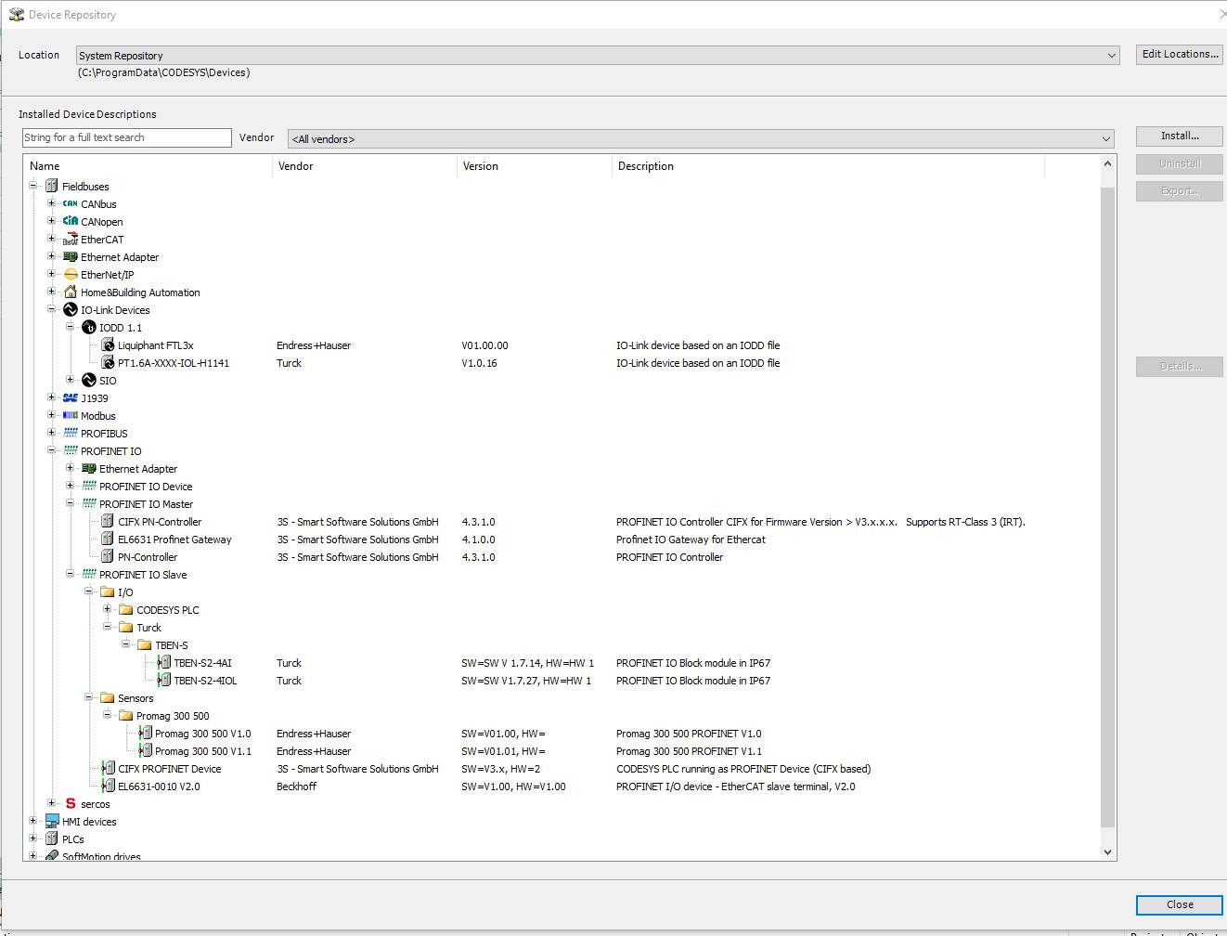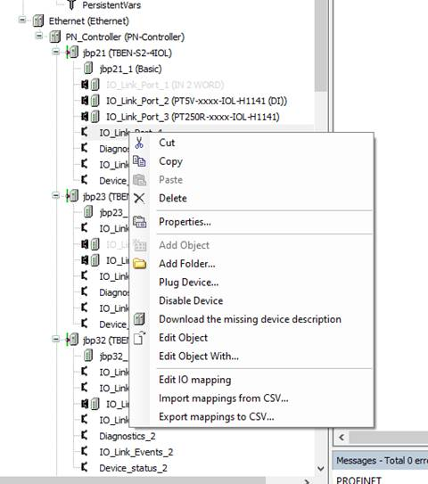
we can see that we were able to plug some IOL sensor from the catalog of Profinet IO-Modules, but we cannot select the IODD device added in the other page because the catalog does not include this IODD devices.
