With CODESYS Control for PLCnext SL 4.0.1.0 loaded this is the message I get when trying to install CODESYS Control for PLCnext SL 4.1.0.0
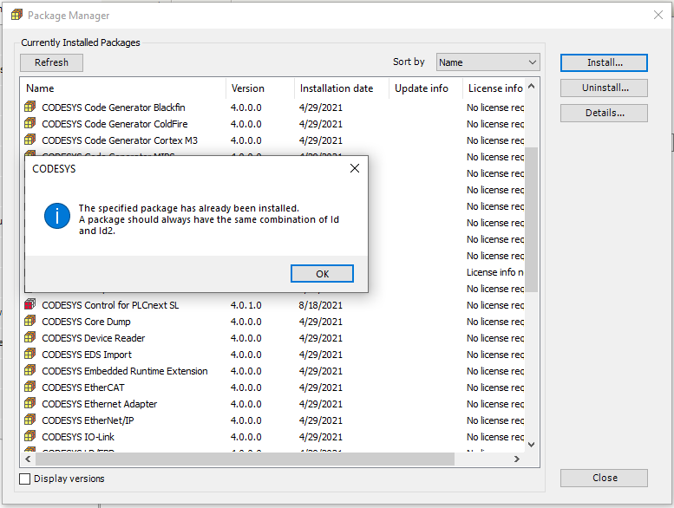

Uninstalled CODESYS Control for PLCnext SL 4.0.1.0

This is the message I get when trying to install CODESYS Control for PLCnext SL 4.1.0.0 (no other PLCnext control loaded)
