I2c Raspberry pi and Arduio uno Connection

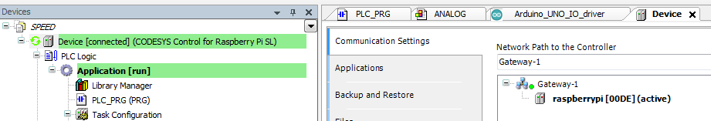

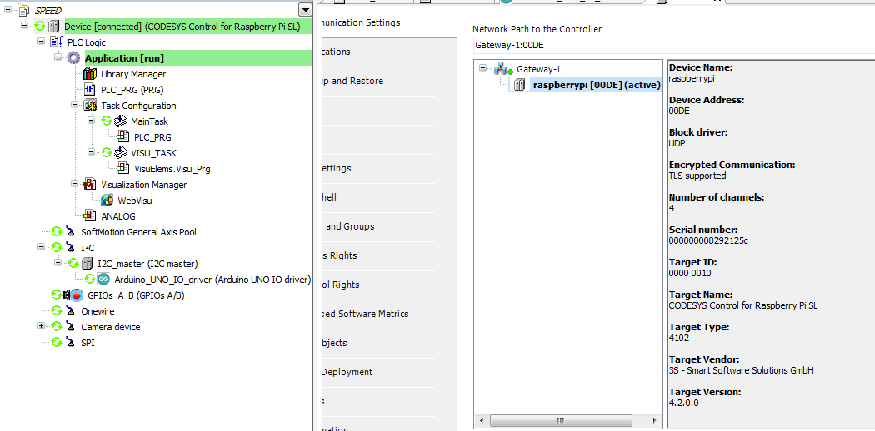

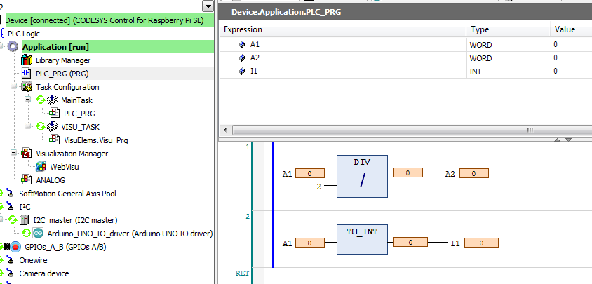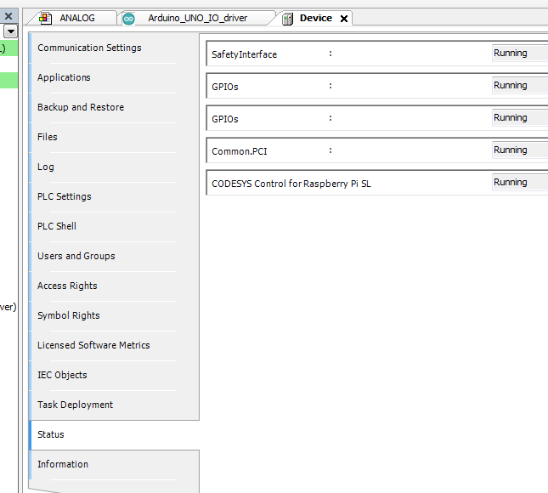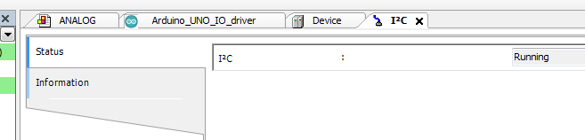

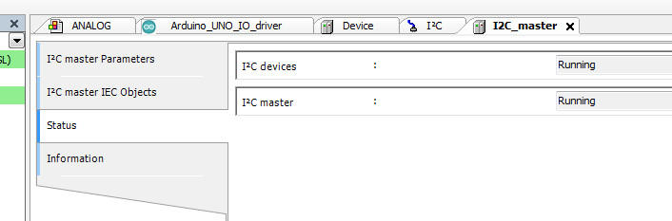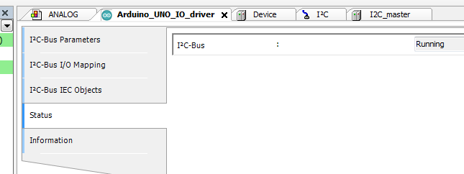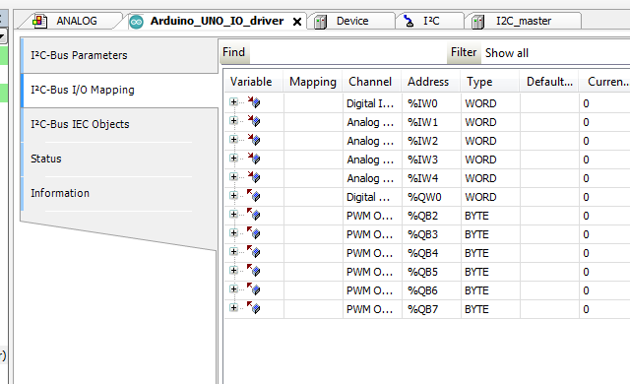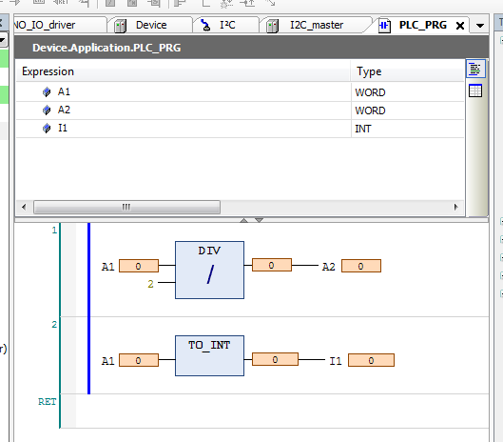

Wiring is also as per requirement

Arduino Uno SCL – connected to SCL Raspberry pi

Arduino Uno SDA – connected to SDA Raspberry pi

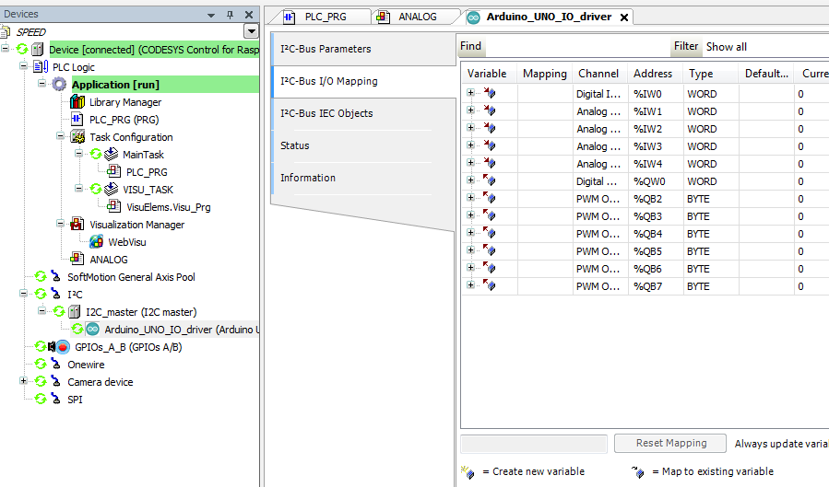

**Codes deployed in Arduino Uno for Slave Device**

const int I2C_ADDRESS = 2;

#include <Wire.h>

volatile int pinConfig;

volatile int PWMConfig;

volatile int digitalIn;

volatile int analogIn[4];

volatile int digitalOut;

volatile int PWMOut[6];

void setup()

{

Wire.begin(I2C_ADDRESS);

Wire.onReceive(receiveEvent);

Wire.onRequest(requestEvent);

Serial.begin(9600);

}

void loop()

{

for (int i = 0; i<14; i++){

bool mode = bitRead(pinConfig, i);

bool pwm = bitRead(PWMConfig, i);

byte pwmvalue;

if (mode)

{

pinMode(i,OUTPUT);

if(pwm){

switch (i){

case 3:

pwmvalue = PWMOut[0];

break;

case 5:

pwmvalue = PWMOut[1];

break;

case 6:

pwmvalue = PWMOut[2];

break;

case 9:

pwmvalue = PWMOut[3];

break;

case 10:

pwmvalue = PWMOut[4];

break;

case 11:

pwmvalue = PWMOut[5];

break;

}

analogWrite(i,pwmvalue);

}

else

{

digitalWrite(i,bitRead(digitalOut,i));

}

}

else{

pinMode(i,INPUT);

}

}

for (int i = 0; i<14; i++){

if (!bitRead(pinConfig, i))

bitWrite(digitalIn, i, digitalRead(i));

}

for (int i = 0; i<4; i++){

analogIn[i] = analogRead(i);

}

}

void receiveEvent(int howMany)

{

byte receiveBuffer[12];

int i=0;

while( Wire.available())

{

receiveBuffer[i] = Wire.read();

i++;

}

pinConfig = receiveBuffer[1]*256 + receiveBuffer[0];

PWMConfig = receiveBuffer[3]*256 + receiveBuffer[2];

digitalOut = receiveBuffer[5]*256 + receiveBuffer[4];

for (int j=0;j<6;j++){

PWMOut[j] = receiveBuffer[6+j];

}

}

void requestEvent()

{

int sendBuffer[5];

sendBuffer[0] = digitalIn;

for (int i = 0; i<4; i++){

sendBuffer[1+i] = analogIn[i];

}

Wire.write((uint8_t*)&sendBuffer,10);

}